The Effect of Mixing Rate on Struvite Recovery from

Petrochemical Wastewater

*Warmadewanthi1)*, Rodlia A., Ikhlas, N.*

*1)Department of Environmental Engineering, Institut Teknologi Sepuluh Nopember (ITS)*

*\* warma@its.ac.id*

**Keywords:** mixing; precipitation; recovery; struvite.

Introduction

PT Petrokimia is a fertilizer company that produces wastewater with high concentration of ammonium and phosphate. High concentration of ammonium and phosphate in water ecosystem will cause eutrophication. One method of reducing ammonium and phosphate can be done by the recovery of ammonium phosphate which produces magnesium ammonium phosphate (MAP) or struvite (MgNH4PO4.6H2O) (Khai, 2012). Struvite is a slow release fertilizer that really important for agricultural purposes.`

Struvite precipitation consists of two stages, nucleation and crystal growth, which affects the particle size (Doyle et al., 2002). Nucleation depends on the rate of initial mixing, while crystal growth depends on the duration of mixing and its velocity (Wang et al. 2006). The purpose of this study was to determine the optimum mixing rate in struvite precipitation.

Material and Methods

This research was conducted by using a batch reactor operated for 60 minutes. A mixture of solution contained [Mg2+]:[NH4+]:[PO43-] of 1:1:1, 1.5:1:1, and 2:1:1 was added into a beaker glass containing 0.5 L wastewater. The pH variations applied were pH 7.5, 8, and 8.5, controlled by adding H2SO4 10 N and 20 N. Stirring was performed using jar test with velocity gradient variations of 106; 0.5 x 106; and 1.5 x 106 for 60 minutes. Subsequently, the solutions were left for 30 minutes to undergo sedimentation process (Warmadewanthi and Liu, 2009). The specified velocities were then converted into rpm units, equal to 100, 158, and 207 rpm, respectively. Parameters analyzed were concentration of residual ammonium and phosphate (mg/L), measured using Nessler Method and Chloride Lead Method. Additionally, the precipitate analysis was also performed based on a chemical prediction by PHREEQC software.

Results and Conclusions

Wastewater used in this experiments contained 2864 mg/L of ammonium and 14656 mg/L of phosphate which was equal to the molar ratio of [NH4+]:[PO43-] = 1:1,03. It was found that the optimum mixing rate depends on the molar ratio used as shown in Figure 1. It can be concluded that the greater molar ratio required higher mixing energy due to the required driving force for the process. It was also found that the amount of precipitate increased with the increasing mixing energy it affected the sedimentation rate. At pH 8 and 8.5 when the molar ratio of 2:1:1 the residual phosphate and ammonium increased due to insufficient sedimentation time for precipitation of struvite in the higher molar ratio of magnesium, ammonium, and phosphate.

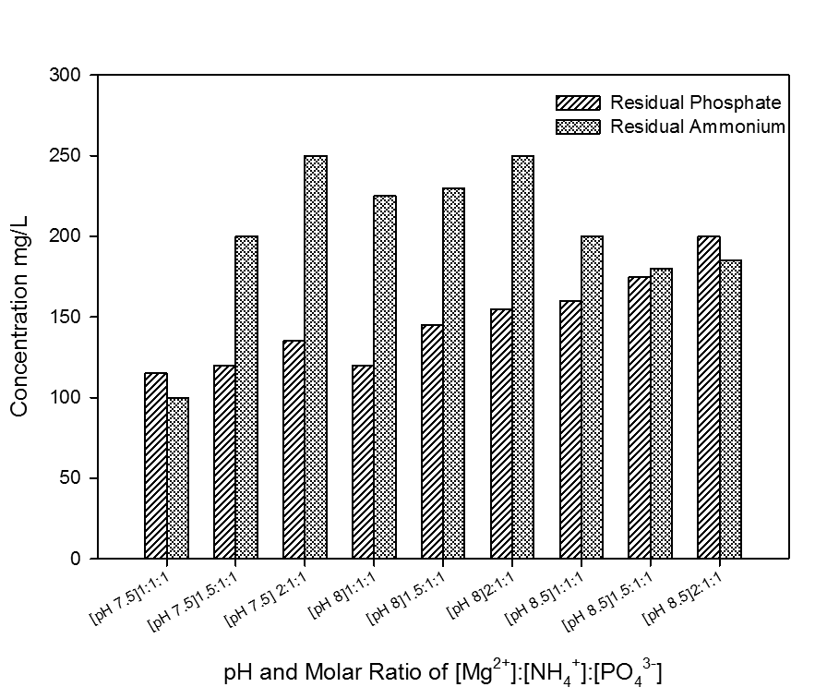

**Figure 1.** Residual concentration of phosphate and ammonium under different pH and molar ratio

High mixing velocities may cause the formation of more precipitates, causing larger crystals to form, allowing even more ammonium bound. Removal of phosphate and ammonium will increase as the rate of mixing increases (Kim, et al., 2007). However, the ammonium removal in this process recovery may decrease with increasing of mixing rate because of the presence of other precipitates. Based on a chemical prediction by PHREEQC, hydroxyapatite was also found in the precipitate, dominantly at pH 7-8. This mineral formation was caused by the existence of Ca2+ in the wastewater, following reaction: 5Ca2+ + 3PO43- + OH- ↔ Ca5(PO4)3OH(s). With 60 minute mixing time and 30 minute sedimentation, mixing rate of 158 rpm was found to be the optimum one, leading to removal efficiency of ammonium 83.60% and phosphate 99.91%.

References

Doyle, J. D. and Parsons, S. A. (2002). Struvite Formation, Control and Recovery. *Water Res*.,**36**(16), 3925-3940.

Khai, N. M. and Hoang T. Q. T. (2012). Chemical Precipitation of Ammonia and Phosphate fromNam Son

Kim, D., Kim, J., Ryu, H.-D., dan Lee, S.-I.(2007b). Effect of Mixing on Spontaneous StruvitePecipitation from Semiconductor Wastewater.*Journal of Bioresource Technology*., 100, 74–78.

Landfill Leachate, Hanoi. *Iranica Journal of Energy & Environment* 3 (Special Issue on Environmental Technology), 32-36

Wang, J., Burken, J.G., and Zhang, X.Q. (2006). Effect of seeding materials and mixing strength on struvite precipitation.*Water Environment Research*., 78, 125–132.

Warmadewanthi and Liu, J.C. (2009). Recovery phosphate and ammonium as struvite from semiconductor wastewater*.Separation and Purification technology.,****64***(1/3), 368-373.